1.a

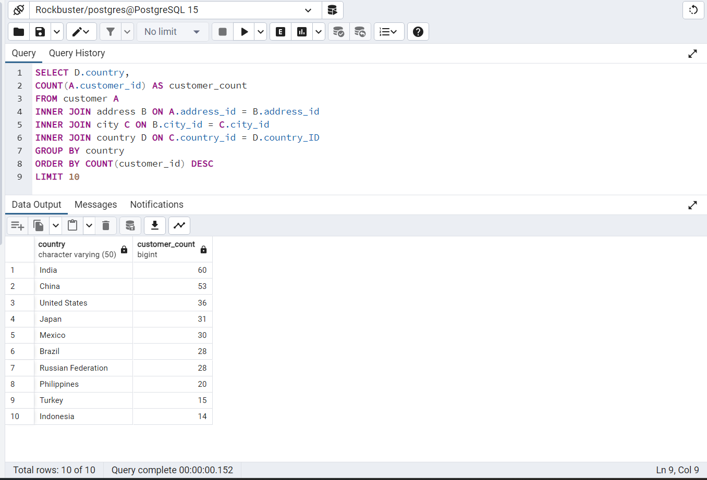

1.b I found the connection keys between the customer and country tables that would help connect both tables. Then I found which columns were necessary for my table to show the results I wanted to present which was customer count grouped by country. The other requirement for this table was that it needed to be limited to the top 10 so I made the order descending and limited to 10.

2.a 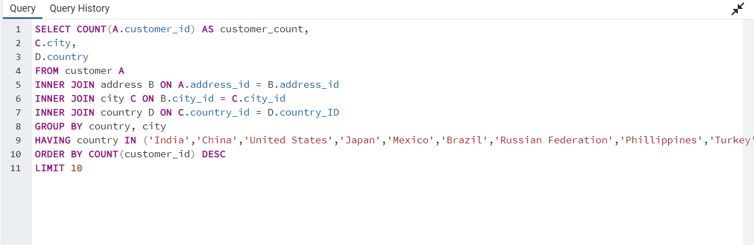

2.b I looked at the previous table and used the countries from that and had my query only look at solely cities from those countries. Then I made the order ascending based on the number of customers and limited it to the top 10.

3.a

